**ASSIGNMENT**

**1) PROGRAM 1:**

print("Question 1...\n")

list = [9,5,8,4,6]

print("The list..")

for i in range(len(list)):

print(list[i])

list.insert(3, 2)

print("\nA) After Inserting Integer 2 at index 3")

for i in range(len(list)):

print(list[i])

list.remove(list[0])

print("\nB) After Removing the first occurance")

for i in range(len(list)):

print(list[i])

list.append(7)

print("\nC) After appending 7")

for i in range(len(list)):

print(list[i])

list.sort()

print("\nD) After sorting")

for i in range(len(list)):

print(list[i])

list.pop()

print("\nE) After pop")

for i in range(len(list)):

print(list[i])

list.reverse()

print("\nF) After reversing")

for i in range(len(list)):

print(list[i])

**PROGRAM 1 OUTPUT**

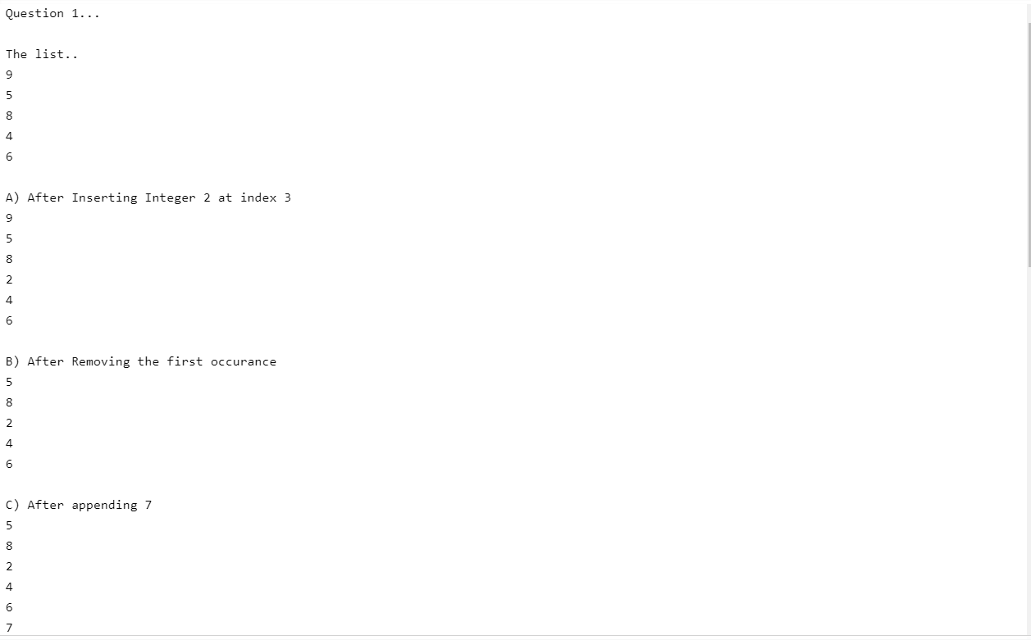

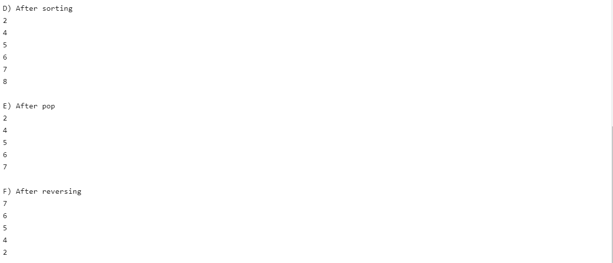

**2) PROGRAM 2:**

print("\nQuestion 2...\n")

n1=30

n2=5

print("Integer 1 : ",n1,"& Integer 2 :",n2)

print("Addition : ",n1+n2)

print("Subtraction : ",n1-n2)

print("Multiplication : ",n1*n2)

print("Division : ",n1/n2)

print("Modulus : ",n1%n2)

print("Exponentiation : ",n1**n2)

print("Floor division :",n1//n2)

**PROGRAM 2 OUTPUT:**

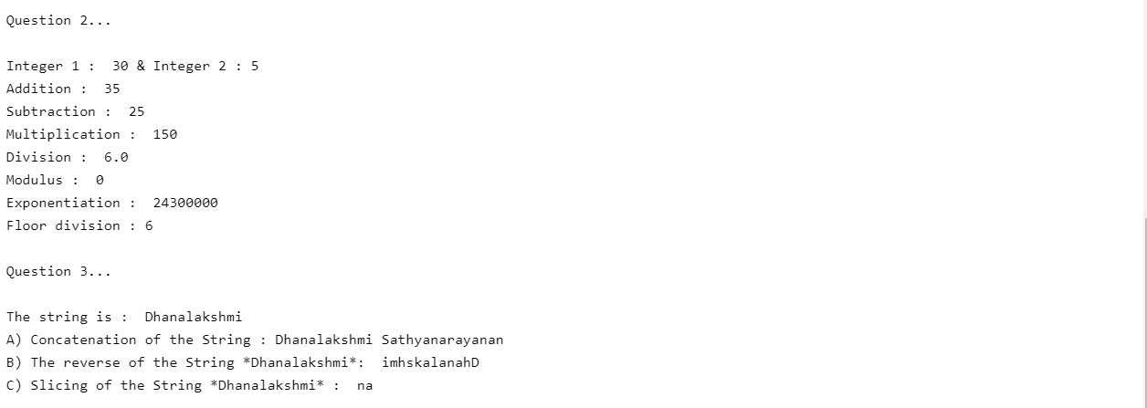

**3) PROGRAM 3:**

print("\nQuestion 3...\n")

str = "Dhanalakshmi"

print("The string is : ",str)

str1=" Sathyanarayanan"

print("A) Concatenation of the String :",str+str1)

str2=""

for i in str:

str2 = i + str2

print("B) The reverse of the String *Dhanalakshmi*: ",str2)

x=slice(3,5)

print("C) Slicing of the String *Dhanalakshmi* : ",str[x])

**PROGRAM 3 OUTPUT**



**4) Why is Python a popular programming language?**

Python language is incredibly easy to use and learn for new beginners and newcomers. The python language is one of the most accessible programming languages available because it has simplified syntax and not complicated, which gives more emphasis on natural language. Due to its ease of learning and usage, python codes can be easily written and executed much faster than other programming languages. Python was created more than 30 years ago, which is a lot of time for any community of programming language to grow and mature adequately to support developers ranging from beginner to expert levels.  [python has excellent libraries](https://www.upgrad.com/blog/top-python-libraries-for-machine-learning/) that you can use to select and save your time and effort on the initial cycle of development. There are also lots of cloud media services that offer cross-platform support through library-like tools, which can be extremely beneficial.

**5)What are the other Frameworks that can be used with python?**

* Flask
* Django
* Pyramid
* Web2py
* Cherrypy
* Sanic

**6)Full form of WSGI:**

 Web Server Gateway Interface.